**Task 2- (Data Cleaning and Visualisation) :**

**Dataset :**

Dataset used : “data.csv”

Libraries to be used :

* Numpy
* Pandas
* Matplotlib
* json
* plotly.express

**Approach :**

First we convert the json data to pandas dataframe and sort the values according to category and amount so that we can get a clear picture of the dataframe.

There is very high possibility that the dataset may contain a lot of duplicate values , hence we need to remove them .

The dataset also contains many unwanted columns ,hence we need to drop them as well

Here we have to create visualization that best answers the question that which segment of users would be interested in our project which is based on Sports and Environment category.

Hence we remove users of other categpry for better visualization

**Code :**

The code for same has been uploaded on the Github

**Output :**

1. Visualisation based on the devices used by the users :

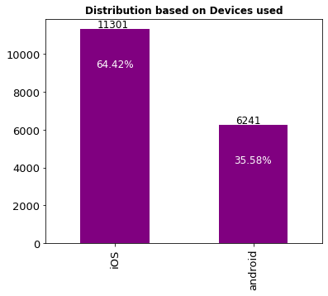

1. Visualisation based on User Participation in events:

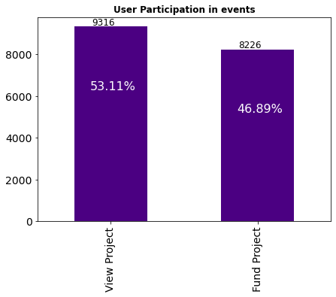

3 . Visualisation based on categories :

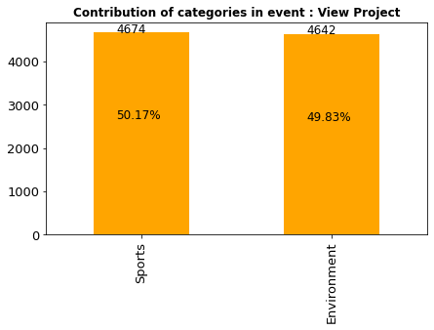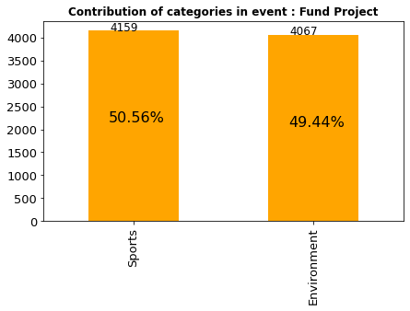

1. Visualisation based on Age-wise participation by users :

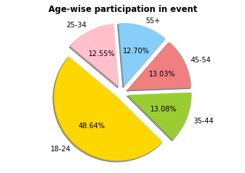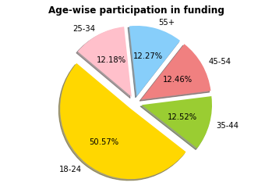

1. Visualisation based on State participation:

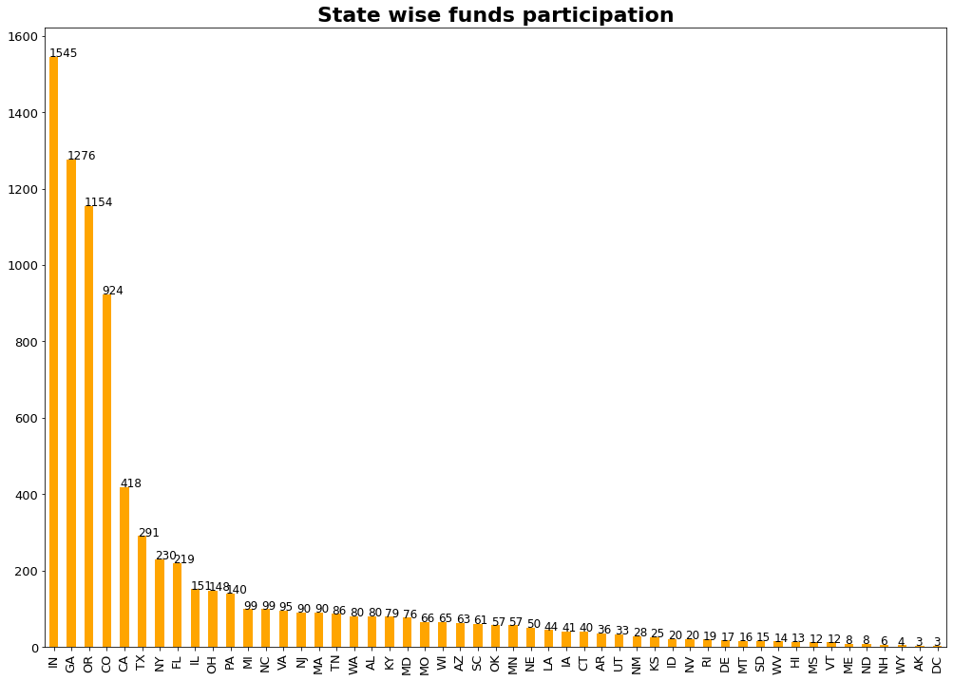

A treemap has been included in the code which allows better visualisationfor each state

1. Visualisation based on Top Cities and State participation:

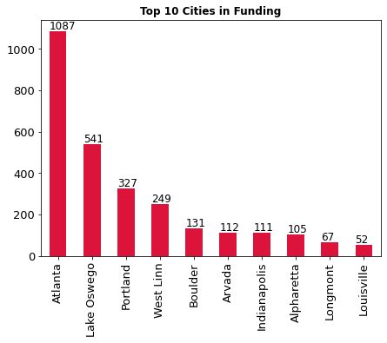

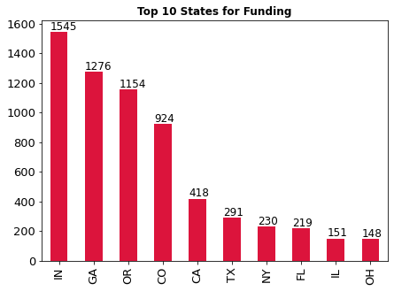

6.Visualisation based on Amount Funded:

